**MySQL TASK IV**

1) Find the names of students who have scored higher than the average score in the subject 'Math'.

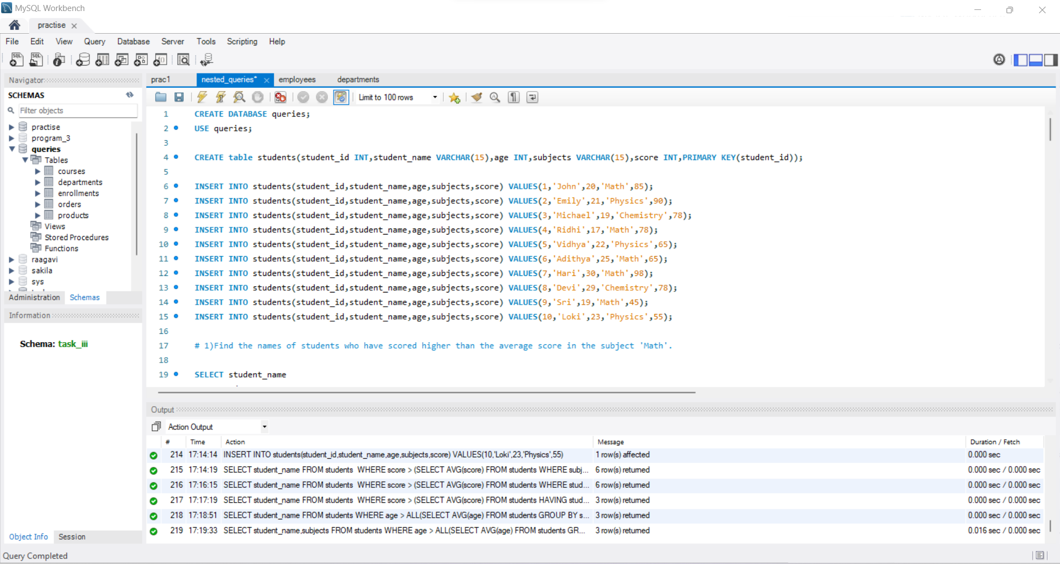

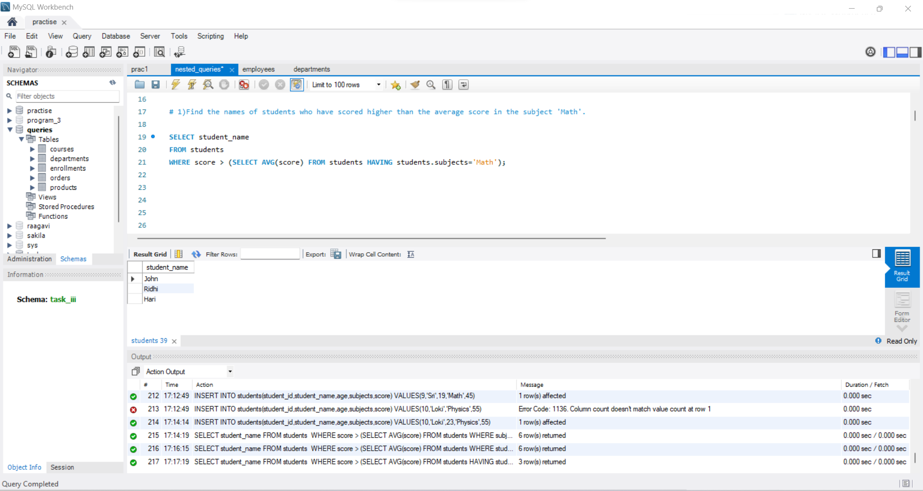

2) Retrieve the names of students who are older than the average age of all students in the same subject.

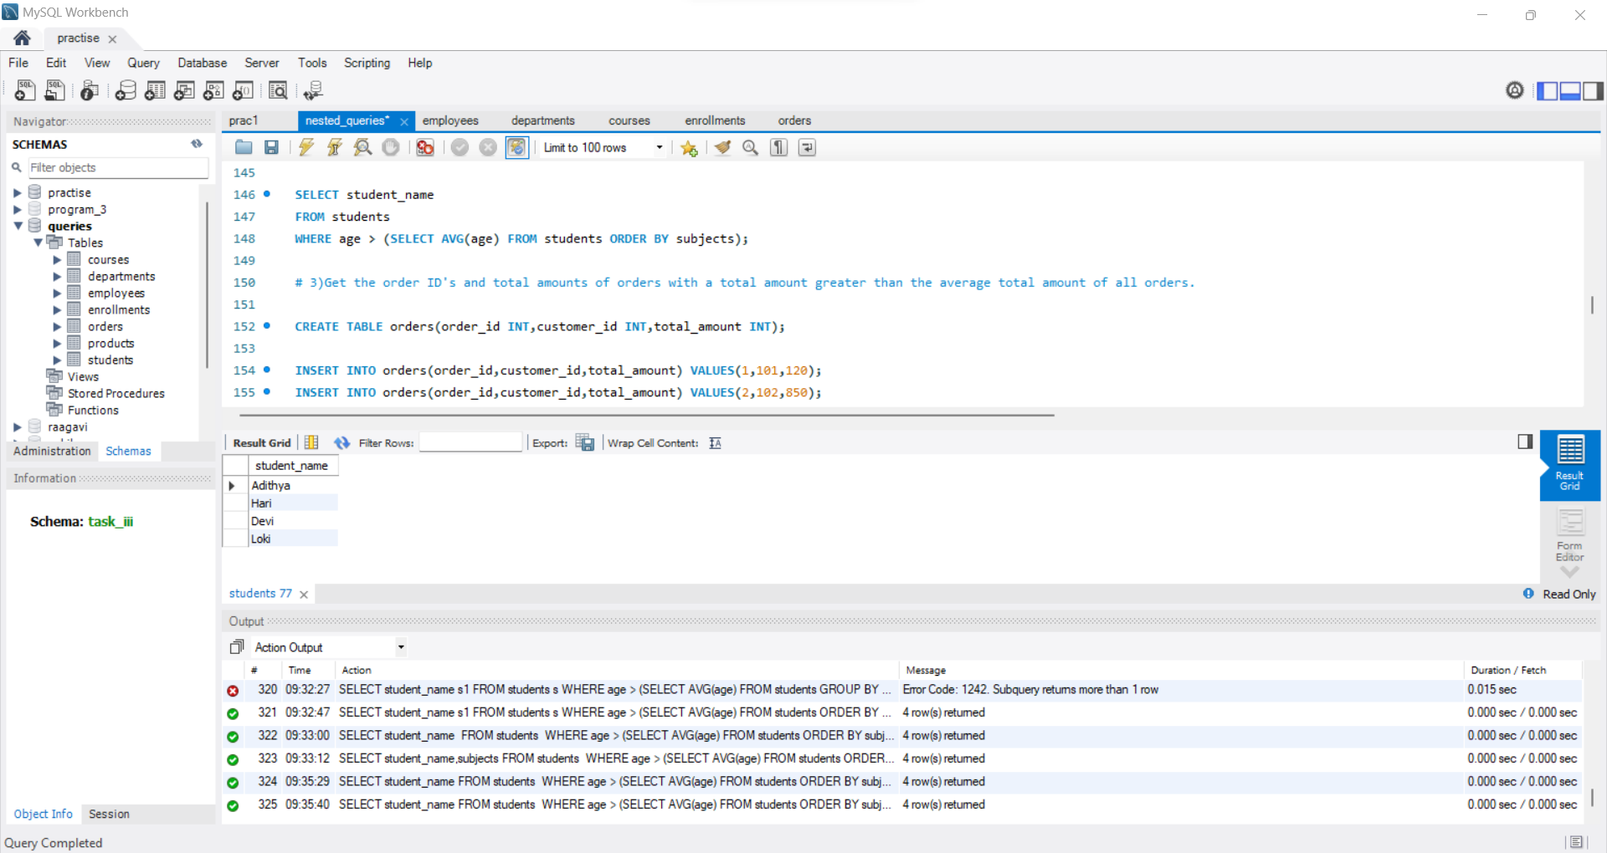

3) Get the order IDs and total amounts of orders with a total amount greater than the average total amount of all orders.

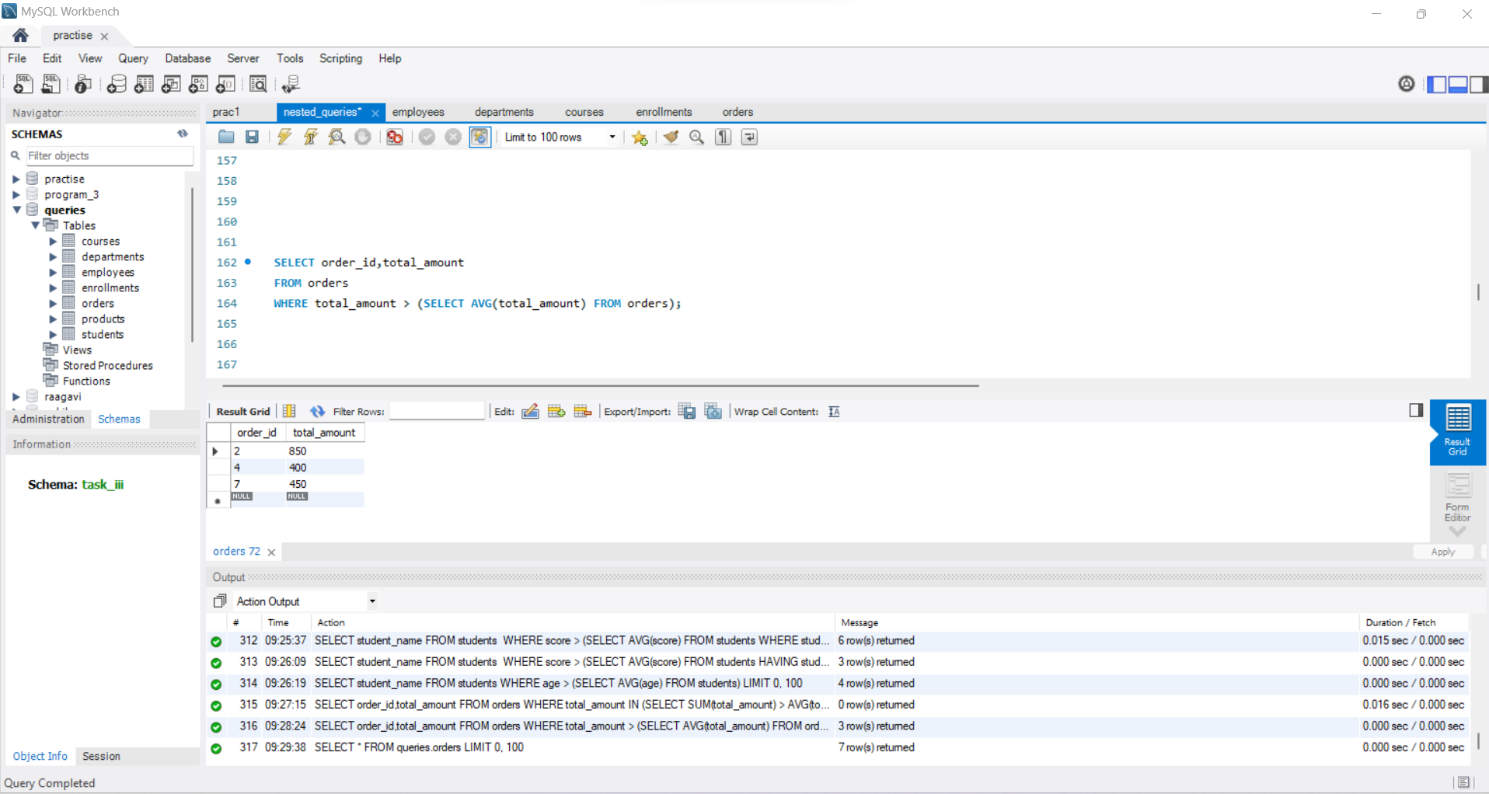

4) List the names of employees who have a salary greater than the average salary of their department.

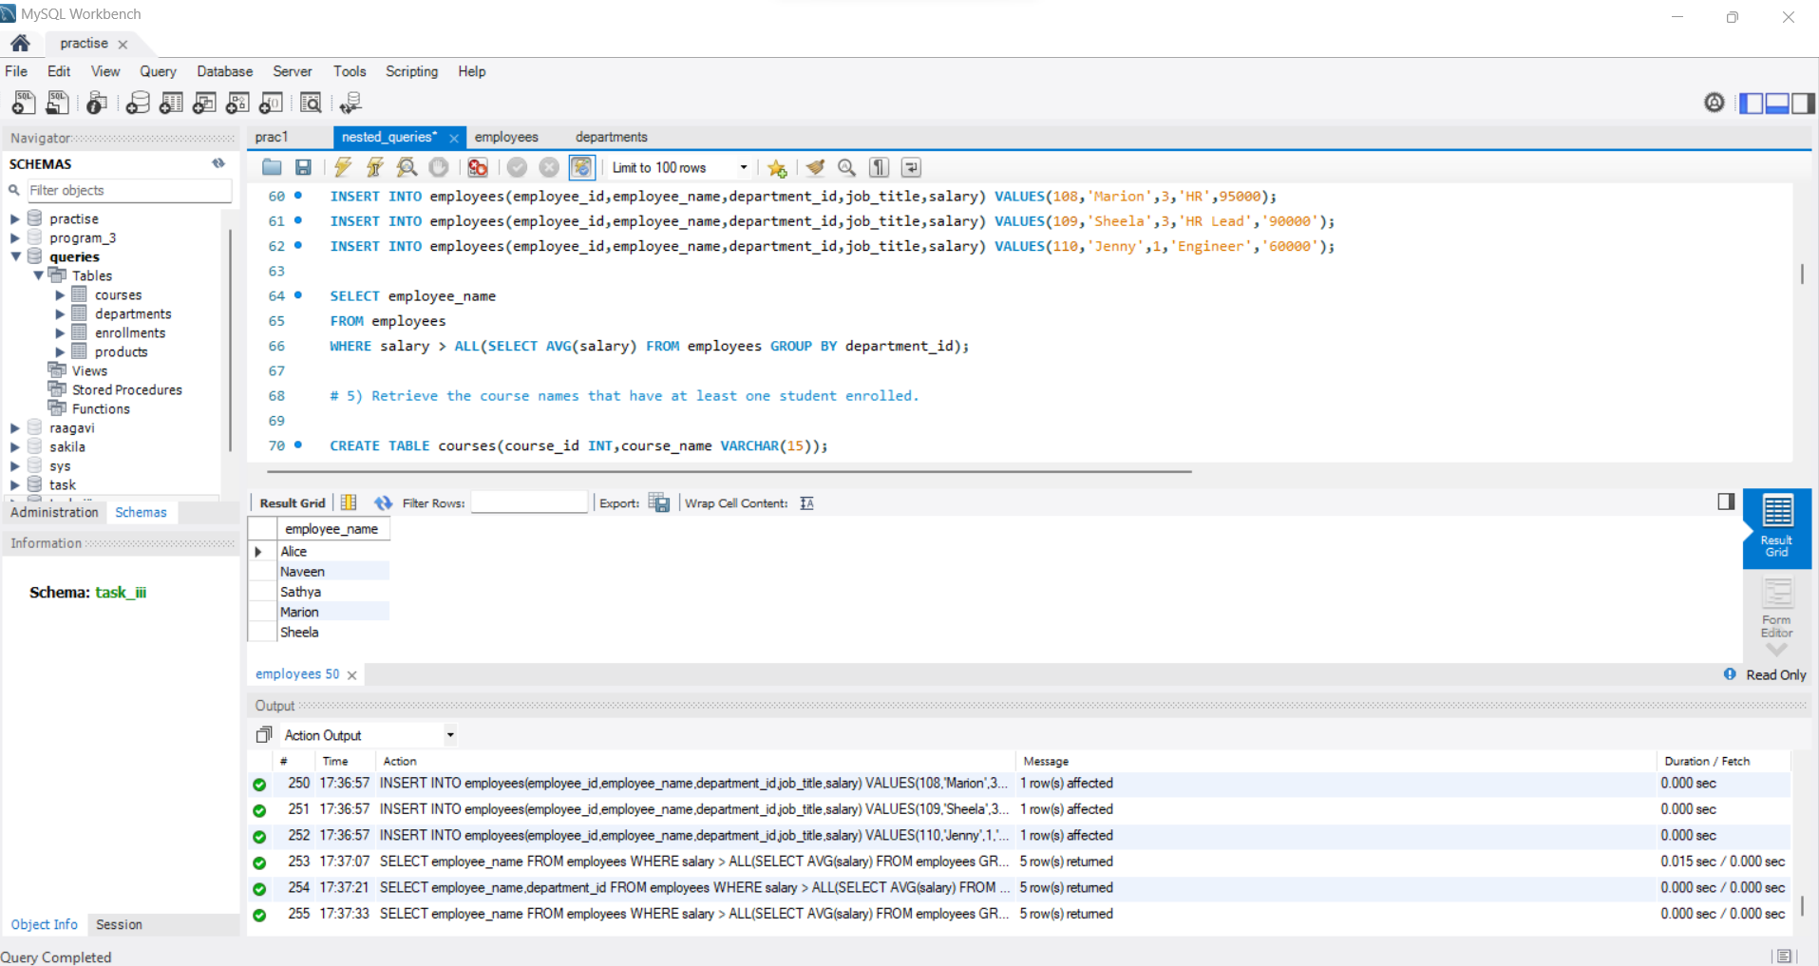

5) Retrieve the course names that have at least one student enrolled.

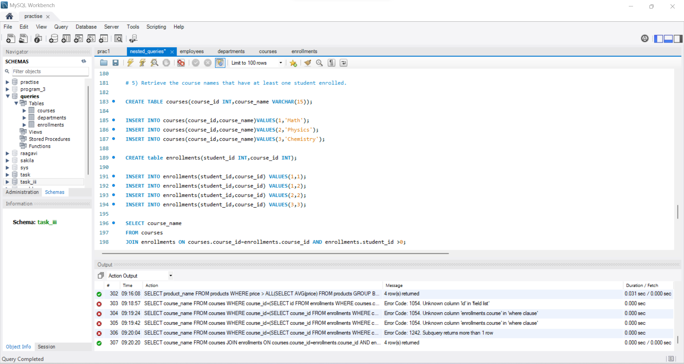

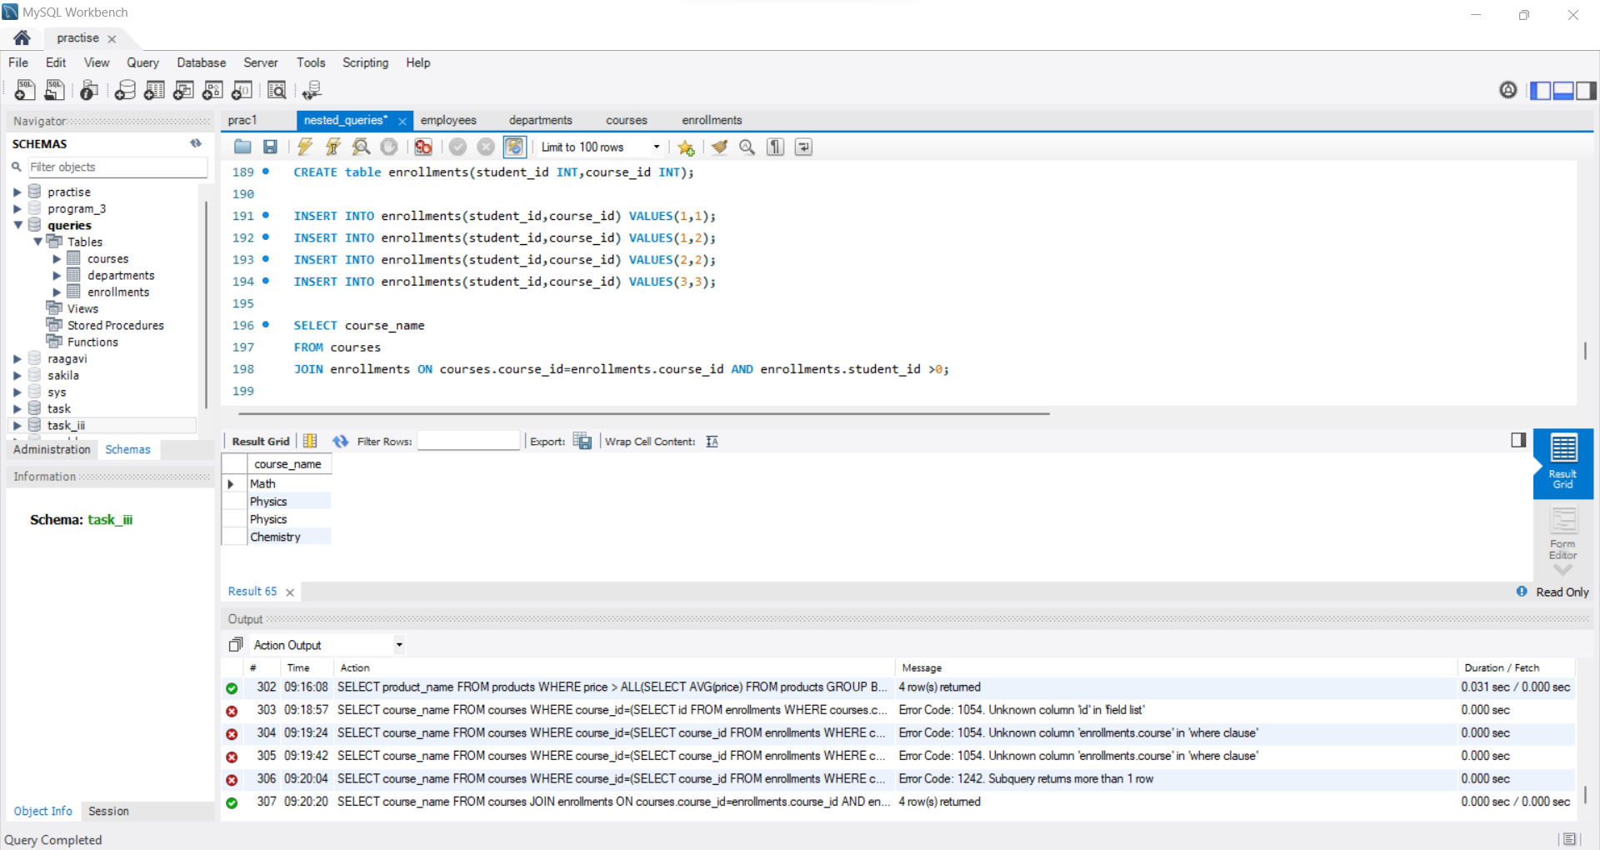

6) Find the names of products whose price is higher than the average price of products in their category.

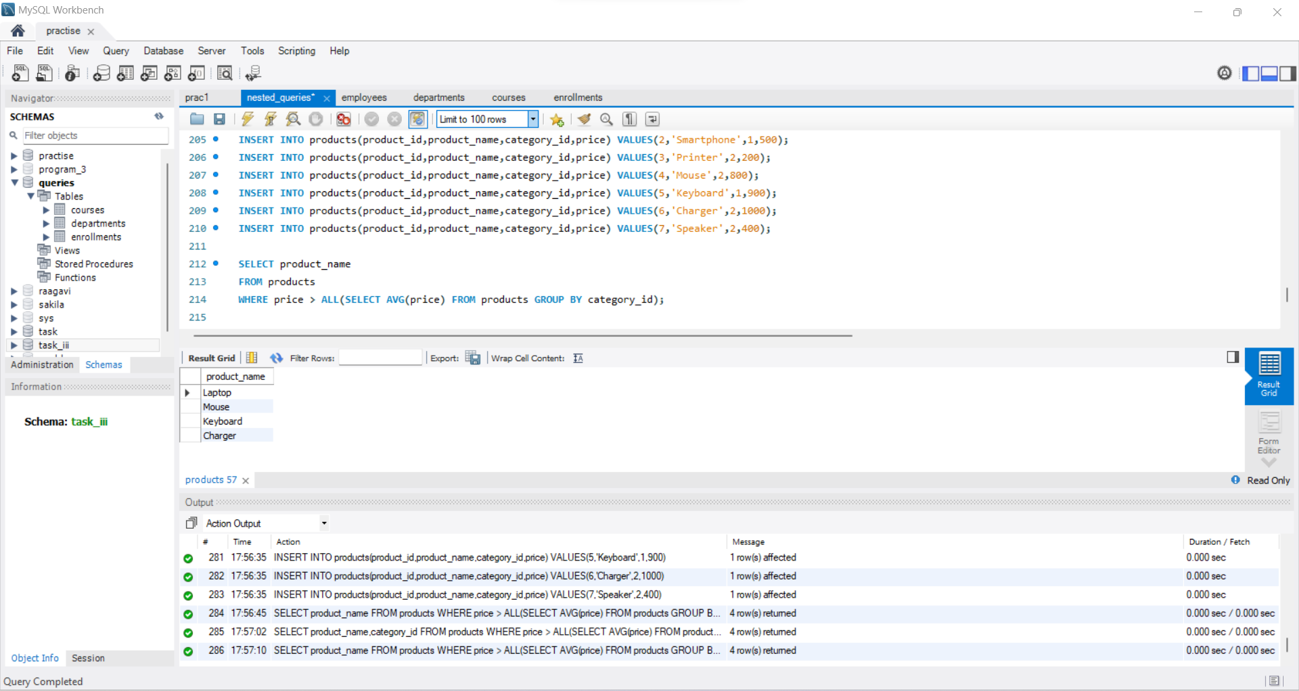

7) Retrieve the names of employees who work in the same department as Clara.

